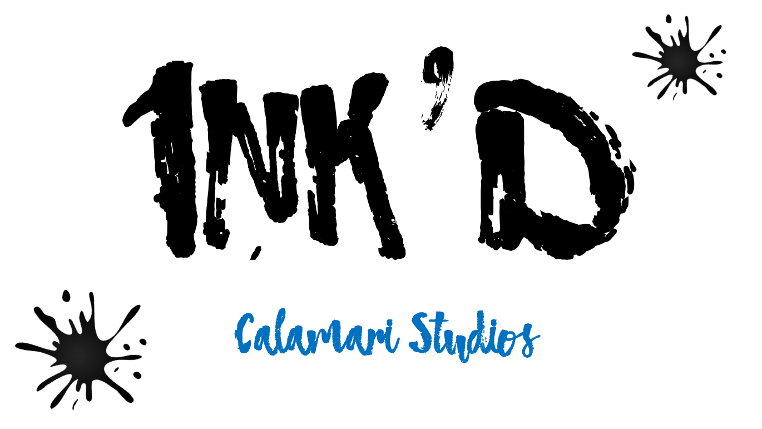
Business Report

Executive Summary

Market Evaluation
Game Value
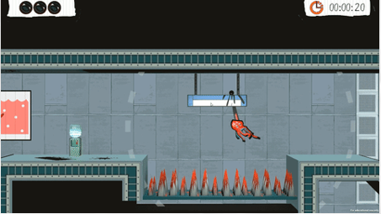
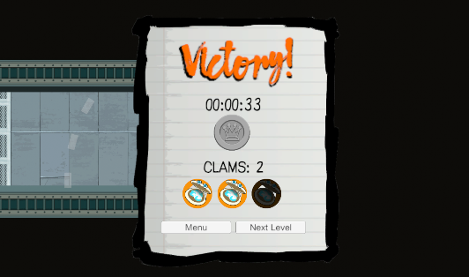
INK’D is a casual game created by Calamari Studios. It is designed to be played on PC currently with the intention of porting to mobile, Android and IOS, in the future.
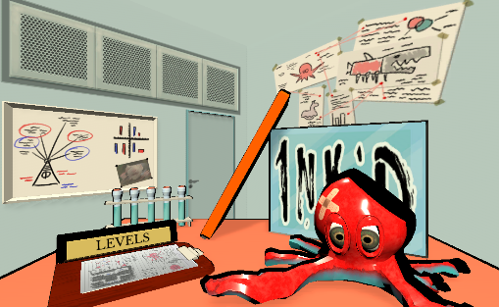
Figure 1 - INKD Main menu page (left), Gameplay (centre), Victory screen (right)
The game brings a new and unqiue movement system that makes it stand out from other games avaliable on the market. This movement system drives many fun and interesting gameplay scenarios. Each level the player is tasked with controlling two octopus arms to fling their way towards the exit. The art style of the game takes inspiration from classic Saturday morning cartoons with colourful main objects and a more muted hand painted style for the backgrounds, helping appeal to the target market. The game features an ongoing story that is told via cutscenes between certain levels and through the mriad of NPC friends the player talks to throughout the levels.
The game has been designed to appeal to casual gamers, gamers interested in experencing unquie gameplay and completionists looking for a low time investment completion game. The game consists of 24 levels, 5 levels and 1 boss level for each world, these worlds all have a different colour style to aid in the feeling of progression. Each level has 3 clams to be collected, and also medals given for completion time. The results the player recieves for these are persitant allowing players to come back and try to improve on their scores. An additional medal is tied to collecting all clams and getting the best time in one run. This special medals unlock special gallery images and even a secret playground level. All of these combined add a ton of replayabilty for the game while still allowing short bursts of gameplay with a feeling of progression.

Marketing Personas
In regards to Bartle Player types INK'D is being created to target the achiever type, for this the game provides medals what the players can unlock on each level with varying difficulty. The other type this game targets is the explorer type, clams are hidden around the levels in sections that would otherwise not be needed to visit, creating additional back tracking with locked doors to access some areas.
The game has been designed to fit with players that have a low amount of time available to play, there is still however scope for a player to burst through the game in quick succession. For this reason the levels are short, it is expected that no level will take longer than 1 minute to attempt to complete. It is unexpected that players will get all collectables and the time medals during the first play of a level, making these levels interesting to retry.
Generally the majority of players will match the personas below of Belinda and Barry which matches with our focus on short gameplay bursts with superficial rewards for those levels. We expect to have a few players like Jordan so we have provided challenging platinum medals for getting all clams and the time medal in one run, making sure those players will have a good amount of challenge to collect everything. Finally we have George, our interesting movement system that can reward the player with incredible fluidity and speed will match with her speed running ideals.

Jordan | Role: Completionist Gamer
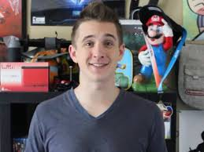  Figure 2 (https://superbeardbrothers.fandom.com/wiki/Greg) | Description  Plays plenty of new indie games, has a lot of time on his hands after work and gets life satisfaction from completing everything a game has to offer.
Quote
You’re not really finishing a game unless you’ve unlocked everything it has to offer.
My favourite collectable has to be the assassin’s creed feathers.
User Goals
Will play the game until they unlock everything.

Belinda | Role: Office worker
  Figure 3 (http://www.hlskc.com/femaleofficeworker27172aabcrozw/) | Description  Works really hard and just needs a little break at lunch to wind down. Usually plays mobile games but has started using her PC for the bigger screen.
Quote
It’s so much fun to play a game for 5 minutes on my break, I like colourful games.
User Goals
Short bursts of gameplay being able to complete a level quickly

George | Role:
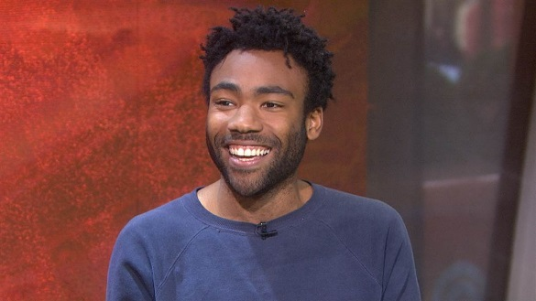  Figure 4 (http://affinitymagazine.us/2016/09/06/my-fellow-black-nerds-we-have-a-problem/) | Description  Streams himself speed running games. Looks for games that let you be quick if you’re very skilled, and spends weeks perfecting his times.
Quote
Gotta go fast.
User Goals
Be the faster at completing the game compared to anyone else.

Barry | Role: College Student
  Figure 5  (https://motionarray.com/stock-video/male-college-student-with-sunglasses-90922) | Description  Spends his day at college and evening doing his homework, manages to take some time to play casual games every now and again so long as his work is done first.
Quote
There’s nothing better than getting straight A’s, but my second favourite thing is getting an early night.
User Goals
Have a quick bit of wholesome fun.

Routes to market
Self-Publishing
From the begging of development we originally planned to self-publish the game. Below is a recap on the estimated outcome if we continue this plan.
Market Position
Our company is currently unknown, giving us no current market position. For the company it is key that we enter the market with a strong first product that is fulfilling to players so that we can start to build a solid brand.
Sales Channels
We are planning to use one channel for sales on initial release, itch.io. However there is a possibility to sell via other channels, if demand seems worth it. If we go on to port to mobile we will be selling via Google Play Store and IOS App Store though this and additional sales channels are not currently being considered so they are left out of this revenue model.
We are estimating an expected sales of 10000 via itch.io only, selling at a minimum net profit of £5 per unit. This is quite a high estimate considering the channel so it is worth keeping in mind that this is by far a best case scenario.
We anticipate a steady climb in sales up to month 3 where sales will peak, then steadily tail out afterwards.
Advertising
We don’t have any money to spend on advertising during development and no team member’s with previous advertising experience. We will however be taking some measures in an attempt to market the game before release. The first is building a social networking profile, by using smartly picked gifs and development blogs to show of unique and polished parts of the game we hope to catch the eye of some media that can spread the word about INK’D . Some team members will be attending conferences anyway and will use these chances to network and advertise INK’D while there. Free copies of the game will be sent out to ‘Influencers’ in the hope that they review/play our game getting it more exposure.
Once we start receiving sales we plan to start spending approximately 10% of our income on marketing via Facebook ad words until the sales start to decline, to drive sales towards the estimate.
Further Work
We will be monitoring sales throughout the process to make sure we stop spending additional money on marketing when planned.

Revenue Forecast
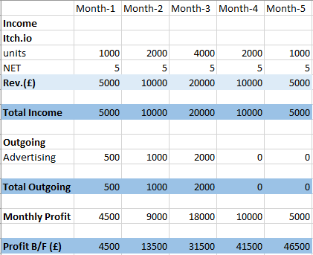
Table 1 - Self-Publishing planned revenue for INK'D

Publisher
We have been approached by a publisher who have offered us a deal to invest an initial £100k to fund working costs and £50k dedicated to a marketing budget. There will be a 50/50 revenue split once the investments have been repaid. Further to this if sales of 40k units are reached within the first 3 months of sales then they will fund us porting the games to 3 consoles (Playstation, Xbox and Swtich). An additional investment of £50k for working costs and £150k for marketing will be given to complete these ports. We will retain the IP but the publisher will have first refusal for additional projects using this IP.
Market Position
We currently don’t know anything about the publisher but it is assumed that they have published games before, and probably good ones, maybe even via steam and consoles.
Sales Channels
We will be selling initially via steam, the publisher has estimated sales between 30k-50k units selling at a price of £15. After VAT and steams cut we will be taking a net of £7.50 per unit sale. Given the publishers previous experience in this market and steams large player base we expect these estimates to be viable.
We again anticipate a steady climb in sales up to month 3 where sales will peak, then steadily tail out afterwards.
If we are to hit the sales target of 40k units in 3 months then the console ports will activate and bring the new sales channels of PlayStation, Xbox and Switch. It is estimated that we will manage to sell 20k units per console, taking a NET profit of £5 per unit.
Advertising
For advertising the publisher will be dealing with how this is managed but below we have put forward our recommendations that we will give to the publisher.
We will continue to do the free marketing that is talked about in the self-publishing advertising section. Additional to this we would like to have a booth at a choice convention close to the release date to spread customer awareness, it will be essential to create and interesting and eye catching booth to draw attention giving we are a fresh IP and company.
Some of the budget would be best spent on getting a professional trailer made, our team has some limited in house trailer creation knowledge, but as this will be many peoples first introduction to the game making sure the trailer is of high quality will increase the chance we leave a lasting impression on the viewers.
We would like to run a real life contest in which the social media platforms we have set up run a campaign that calls for help finding the escaped octopus, a model of our octopus will be placed in the real world with cryptic clues given out to lead the public to their location. The first person to find the octopus will get to keep the one of a kind model and win a free copy of the game.
Revenue Model
We will be have a 50/50 revenue split on NET profit with the publisher. Revenue will be gathered from pure unit.
Revenue Forecast
Minimum estimated sales
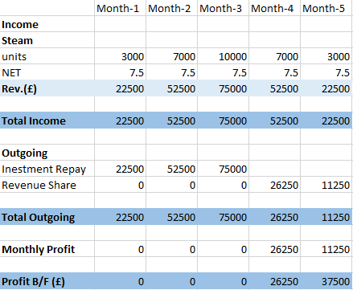
Table 2 - Publisher minimum estimated sales planned revenue for INK'D
Maximum estimated sales
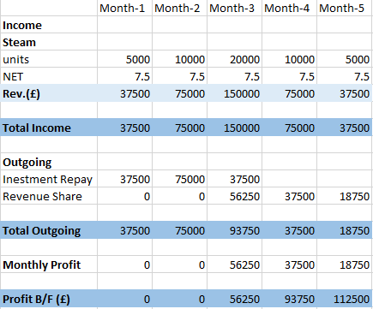
Table 3 - Publisher maximum estimated sales planned revenue for INK'D
Console sales
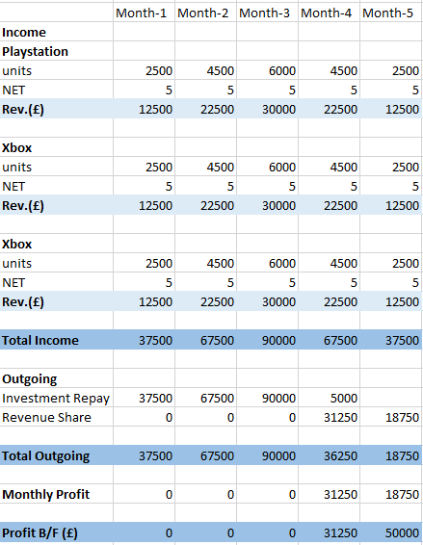
Table 4 - Publisher estimated console sales planned revenue for INK'D

Development Plan
We are using an agile approach to the development of this project, taking many principles from the agile philosophy that fit with our team. Therefore we don’t have a laid out plan for specific sections of the game, we do however have some time scales that we are aiming to hit.
We currently plan to have the game deliverable within a 6 month period. A large majority of the game is already complete and we plan to content lock after two more months. The next two months after that will be focused on polishing the game to the best standard possible. The remaining two months will be a combined approach of beta testing the game and fixing bugs that arise during those tests, along with continuing to polish when possible. Due to the way we have been consistently been play testing the game through development, we don’t expect any more major gameplay changes.
Self-Publishing
After releasing the game there are a few routes the company can take. We can call it a day and take the income we get from sales, then look for other work. Alternatively we can stick together and prototype a new idea.
Cash Flow Forecast
The cash flow forecast below is what we expect to see if we achieve our estimated sales. We are not taking any pay while working on the game as we have no money to pay ourselves. Once sales start coming in the company profit is split evenly between all team members.
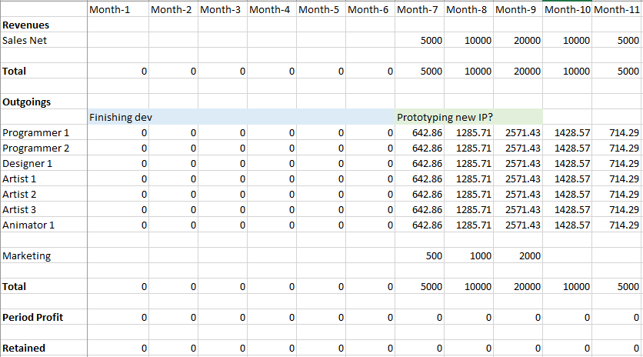
Table 5 - Self-publishing cash flow forecast

Publisher
If we take the publisher deal we will continue with the original plan for the first 6 months of development. We are all taking an even wage given the similar experience levels across the team, however we will not be able to fairly fund all team members for the course of the whole project. On the forecasts below it is shown as they have been let go from the project. Realistically though the company will be looking to find outsourced work for these team members so that we can fund their salary. These will be considered as separate projects though and are therefore not shown on the forecasts.
Cash Flow Forecast (Min estimated sales)
This forecast demonstrates the cash flow if we are to reach the minimum estimated sales given by the publisher. Even with minimum sales we are able to fund prototyping of the next IP with the company still having a profit.
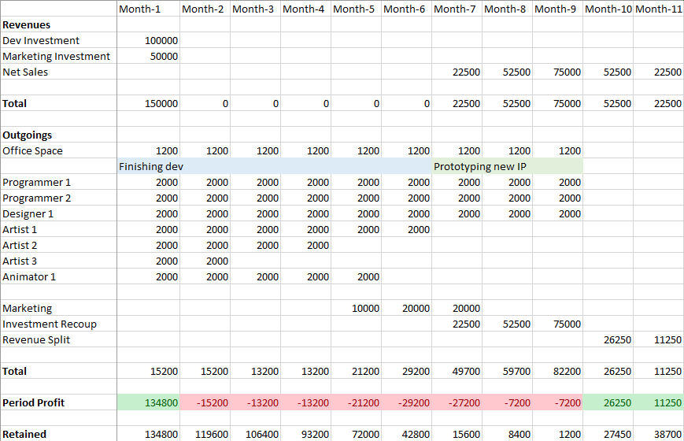
Table 6 - Publisher minimum estimated sales cash flow forecast

Cash Flow Forecast (Max estimated sales)
The two cash flow forecasts below are based on us hitting the maximum estimated sales given by the publisher. Therefore they go on to encompass the console porting work and sales.
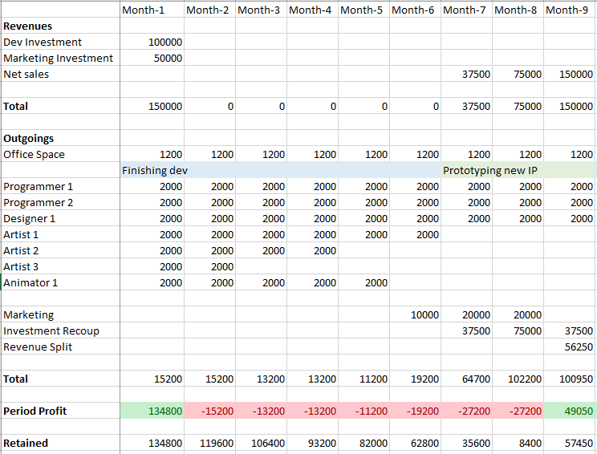
Table 7 - Publisher maximum sales cash flow forecast (part 1)
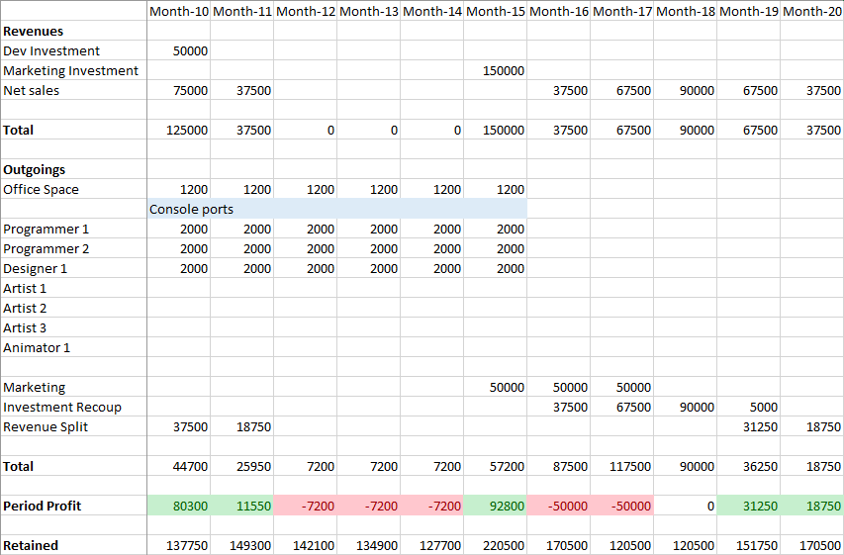
Table 8 - Publisher maximum sales cash flow forecast (part 2)
Conclusions
Assumptions and Risks
Assumption | Detail | Impact | Action
Estimating 10k sales via Itch.io | We are estimating sales of 10k units when self-publishing via itch.io. These figures seem to be a lot given the channel and marketing budget. | If we don’t reach these sales then the profit to share between the team will be lower. | Double check the research done to create this estimate.
Publisher sales estimates are accurate | The sales predicted by the publisher are much higher than those we expect when self-publishing | If we don’t meet the assumed sales we may not be able to repay the investment. | Take a look into sales reached on steam for similar games. Check with the publisher to see the sales of other games they have published.
Able to find outsource work for team members | We want to find contracts that our company team members can do when not working on the project to keep the team together. | If we can’t find work for the team then some member’s will have to be let go, at least until the next project. | Start enquiring about outsource work and actively show that our company is able to take on extra projects.
Table 9 – Assumptions and risks table
Accuracy of publisher information
As mentioned in the risks table above currently the sales estimates are based entirely on assuming the publisher has given us accurate information. We will need to make sure with the publisher that the investment is only to be repaid if we manage to make sales, given that all staff members are being paid it would be acceptable for the company to not make profit so long as we are not forced into a negative balance.
It is worth considering that none of our team have experience in working on consoles. The publisher assumes we can port to 3 different consoles in the space of 6 months with a small team. There is scope for this to go quite wrong. It costs us £6000 a month to staff for the ports, with the £50k working costs they are investing we can afford to bring in an additional programmer for the project that has previous experience in porting to consoles to mitigate this possible problem.
It will be worth talking to the publisher to see if they have done this with any other companies and look to talk to those companies to see how the pots went for them.
Brand Growth
Seeing as this is our first project the current lack brand awareness will mean that we don’t have a base of customers that will already be interested in our games. For self-publishing this will be a real issue as we have no marketing budget. Whereas with a the publisher deal they are dedicating a lot of money to a marketing budget which will not only help our sales but give us reach to spread our brand for future projects, this is increased more if we manage to hit the sales for console ports with an even greater marketing budget and much wider market.
Recommendations
Firstly we need to work our way through the risk actions that are relative to the publisher deal presented in table 9. We do not recommend going down the self-publishing route therefore the risks attached to that can be ignored unless the publisher deal falls through.
As just mentioned we advise scrapping the self-publishing route in favour of taking the publisher deal, this is due to many aspects.
Appendix 1 – Self-Publishing Proposal
Our current group is taking the game to market using Itch.io as the sole distributor. We are all working remotely from our own homes living without a wage. We are estimating the game will sell 10k units and have agreed a minimum net profit of £5 per unit, once pricing and other costs have been assessed. We anticipate production will require six more months to make the game polished and functionally complete. After which, we have several game ideas we would like to develop. So far, the team enjoys working together and you all feel that we are getting good results.
Appendix 2 – Publisher Proposal
The publisher will fund up to 12 months (about £100k of development) using the current team through an advance that will be recouped against sales. There is a local business park that can accommodate the whole team and provide suitable development machines and associated resources for £1200 per calendar month.
The game will be initially release on Steam at a gross price of £15. The publisher will commit a further £50k marketing advance that will be also be recouped against sales. The publisher estimates that the game should sell between 30-50,000 units and once the initial advances have been recouped; there will be a 50:50 royalty split. Once the game meets the upper end of the sales targets (40,000 units), console ports will be triggered. This will be a go / no go decision after 3 months of sales data and the PC version will be launched as soon as it is complete.
For console ports, the publisher will provide a £50k advance for development of PS4, Xbox One & Switch skus. It is expected that all 3 versions can be turned over within 6 months and a skeleton team of 2 programmers and a producer / designer will be required working across all plat- form skus. The publisher will manage all sku testing.
On completion, the publisher will commit a further £150k marketing advance to ensure that the game will get great coverage on release. Console targets suggest an average of 20,000 sales per platform with average net revenue of £5 per sale and this would be split 50:50 once advances had been recovered. The developer would retain ownership of the current IP, though the publisher would retain the right of first refusal on publishing future development work with the IP. Further work on novel IP would be discussed on completion of the console versions.

